**Invasive Species**

Multiple Choice

1. Define the term native species.
2. A species that does not naturally occur in an ecosystem.
3. A species that naturally occurs in an ecosystem.
4. A species that can populate ecosystems easily and quickly.
5. A species that reduces the biodiversity in an ecosystem.
6. Define the term introduced species
7. Species that cause damage to the environment and disrupt the food chain.
8. Species that have been released into an environment where they aren't naturally found.
9. Species that are in danger of becoming extinct in their natural habitat.
10. Species that do not interact with other parts of their native environment.
11. Species that require a specific habitat in order to grow and reproduce.
12. Determine when an introduced species becomes an invasive species.
13. When it increases biodiversity in the ecosystem it was introduced into.
14. When it builds a spaceship and starts conquering other planets.
15. When it begins to damage the ecosystem it was introduced into.
16. When it becomes separated from every other species in the ecosystem it was introduced into.
17. Define the term generalist species.
18. A species which is quick to colonise areas, due to their fast growth.
19. A species which can only survive in specific conditions.
20. A species that can survive in a broad range of environments.
21. A species which reproduces quickly and efficiently.
22. Identify how introduced species can be moved into new ecosystems. Select all that apply.

Select ALL correct options

1. Within clothes and other human cargo.
2. By being blown across water by the wind.
3. Within wooden products e.g. shipping crates.
4. Via ships or other forms of water transport.
5. Identify what characteristics help invasive species to thrive in their new habitat. Select all that apply.

Select ALL correct options

1. The ability to reproduce both sexually and asexually.
2. The ability to survive in a broad range of habitats.
3. The ability to reproduce and grow quickly.
4. Being vulnerable to disease and predators.
5. State whether the below sentence is true or false.

"Introduced species' and 'invasive species' mean the same thing."

1. True
2. False
3. State whether the below sentence is true or false.

"Invasive species tend to decrease the biodiversity of the area they're introduced into."

1. True
2. False
3. State whether the below sentence is true or false.

"Invasive species have economic (monetary) impacts."

1. True
2. False
3. State whether the below sentence is true or false.

"The red kangaroo, koala and platypus are considered invasive species in Australia."

1. True
2. False

Short Answer

1. The cane toad (Rhinella marina) has thrived in the north-east of Australia. There are now over 200 million of them in the country, spreading diseases and poisoning any predators that try to eat them.

Using the cane toad as an example, explain what an invasive species is. Include some characteristics of invasive species that give them an advantage over native species.

1. Describe, in your own words, at least THREE negative effects of invasive species. Consider their economic, environmental and ecological impacts.

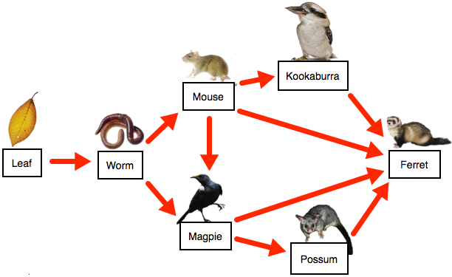

1. Look at the food web above. Deduce what would happen if a leaf-eating germ were accidentally introduced.
2. Look at the food web above. Predict what would happen if a wild cat were introduced?

(Hint: The wild cat is a fourth order consumer.)